|  |  |  |
| --- | --- | --- |
| shampoo and conditioner… | cat or dog food… | anti-perspirant deodorant… |
| a packet of biscuits… | a jar of coffee… | a carton of juice… |
| UHT milk … | A Box Of Chocolates | a jar of mayonnaise… |
| some custard… | some lovely smellies… | and a tinned pie  C:\Users\Foodbank\Downloads\IMG-0440_orginal_sketch.jpg(from Fray Bentos). |

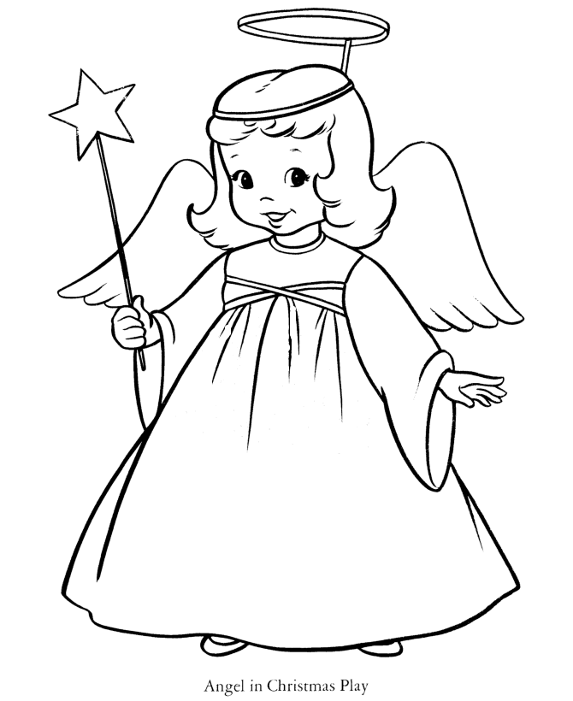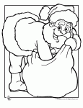On the 12 Days of Christmas, I bought for Whitehawk Foodbank